U


MATHEMATICS DEPARTMENT 2015
Year 11 Specialist - Test Number 2
Mathematical Proofs and Counting Methods

Name: _______________________________ Teacher: __________________
Marks: 43
Time Allowed: 45 minutes
Instructions: You are permitted your calculator but no notes.
_________________________________________________________________________
Part A
8 multiple-choice questions
1 mark each: 8 marks
Circle the correct answer.

1 Which of the following is a counter-example to the argument below?
If a > b then
A a = 4, b = 3
B a = 1, b =
C a = 10, b = 0.1
D a = −2, b = −3
E a = 3, b = −3
[1 mark]
2 The inverse of P Q is:
A P Q
B Q P
C Q P
D P Q
E Q P
[1 mark]
3 Which of the following is the contrapositive of the statement below?
If sport stars are paid more then they play better.
A If sport stars play better then they are paid more.
B If sport stars do not play better then they are not paid more.
C If sport stars are not paid more then they do not play better.
D If sport stars are paid more then they do not play better.
E If sport stars play better then they are not paid more.
[1 mark]
4 Which of the statements is the correct translation of the following?
For all real x there exists a positive real number y
A ∀ x ∈ N, ∃ y > 0
B ∀ x ∈ R, ∃ y ∈ R : y > 0.
C ∀ x ∈ Q, ∀ y ∈ R, y > 0
D ∀ x ∈ R, ∀ y > 0, y ∈ R
E ∃ x ∈ R, ∃ y ∈ R, y > 0
[1 mark]
5 How many 4 letter ‘words’ can be made from the word EQUALS if Q must be followed by U, and you cannot have QU last?
A 360
B 144
C 156
D 180
E 240
[1 mark]
6 How many students must be taken at random from a class to be sure of getting two with birthdays in the
same month?
A 7
B 12
C 13
D 366
E 6

[1 mark]
7 How many different anagrams of the word PARALLEL are there?
A 40 320
B 336
C 6720
D 120
E 3360

[1 mark]
8 In how many different ways can 6 different people be arranged in a circle?
A 120
B 720
C 360
D 60
E 1440

[1 mark]
Part B
8 short answer questions
24 marks
Show your working where appropriate.
9 a Write the converse of the statement:
If you are a bilby then you are endangered.

b Decide whether or not the statements are an equivalence. Justify your answer.

[3 marks]
10 Find a counter-example for this statement:
If x2 > 16 then x > 4.

[1 mark]
11 a Prove ΔABC ||| ΔEDC.
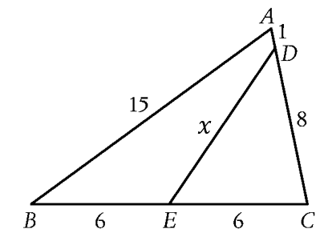

b Hence find the value of $x$.

[4 marks]
12 Consider the contrapositive statement:
If you do not eat cane toads then you do not get sick.
a Write the original statement.

b Decide whether the statement and its contrapositive are true. Justify your answer.

[3 marks]
13 In the diagram, PQ || RS and TQ bisects ∠PQS and TS bisects ∠RSQ.
Prove that ∠QTS = 90$°$.
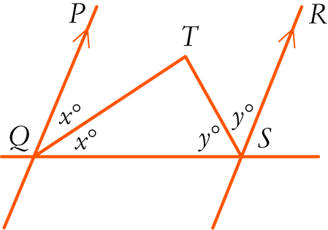

[4 marks]

14 Kate has 6 different tops, 5 different skirts and 3 pairs of sandals. How many different outfits can she make by choosing one of each?

[1 mark]
15 How many 4 letter ‘words’ can be made from the letters of MALTED if the second or third letter must be
a vowel? Words with two vowels are permitted, but no letters are to be repeated.

[4 marks]

16 A queue for rock concert tickets has 3 couples, 4 people on their own and a group of 3 friends together in a single line. In how many different ways could they be lined up? (Obviously assume each couple stands together as a couple and the 3 friends stand together.)

[4 marks]
Part C
3 analysis questions
11 marks
Show your working where appropriate.
17 A large circular table at a restaurant has 9 people from an office seated at random around it.
What is the probability of Mary being seated between David and Peter?

[3 marks]
18 Decide whether this argument is valid or invalid. Give reasons for your answer.
If you speed on the road then you are an idiot.
I am an idiot.
Therefore I speed on the road.

[2 marks]
19 Using vectors, prove that in a triangle, if a line is drawn from a point that divides one side in a given ratio, parallel to a second side, then it divides the third side in the same ratio.
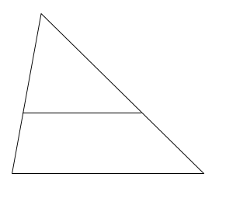

alternate proof:
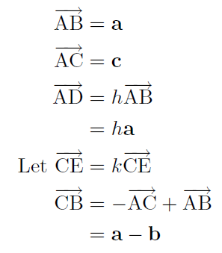
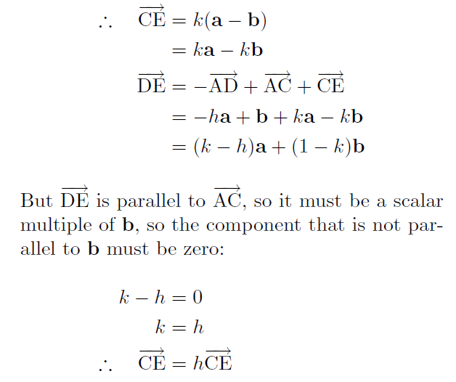

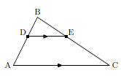
[6 marks]

End of test

